Chapter 4: System Implementation

4.1 Introduction
This chapter details the implementation of the proposed detection system, translating the methodology from Chapter 3 into a working prototype. We describe the development environment, tools, and technologies used, as well as the architecture of the system’s components. Key aspects include the experimental setup and software stack (encompassing the backend API, machine learning model integration, and frontend interface), the generation of steganographic samples for testing, and how the YARA rules and ML model were implemented in code. We then explain how the signature scanner and anomaly detector were integrated into a unified pipeline within the backend, and describe the overall system workflow, from image upload to threat report. Where relevant, we include code snippets and system commands to illustrate the implementation. Screenshot placeholders and diagrams are provided to visualize the system architecture and user interface. By the end of this chapter, the reader should have a clear understanding of how the system was built and how it operates in a deployed setting.

4.2 Experimental Environment
The development and deployment environment for the system leveraged a mix of local and cloud-based tools to simulate a real-world based scenario. The hardware, software frameworks, and cloud services used are basic free or low tier application and leveraging my personal computers:
Hardware
Development and initial testing were performed on a standard PC with an Intel® Core™ i7 CPU and 32 GB of RAM, running Windows 11 PRO. This provided sufficient processing power for image analysis and model inference. For training the machine learning model, the same machine was used; the dataset size and model complexity were light enough that no specialized hardware (like GPUs) was required. The final deployment was containerized and run on cloud infrastructure with similar resource specifications (approx. 2 vCPUs, 4 GB RAM) to ensure the system could handle moderate load (scanning a few images concurrently) with low latency.
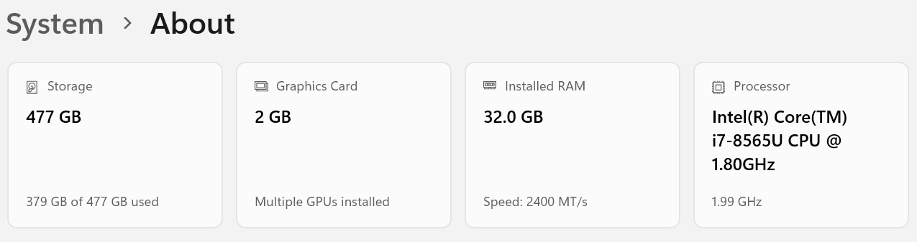
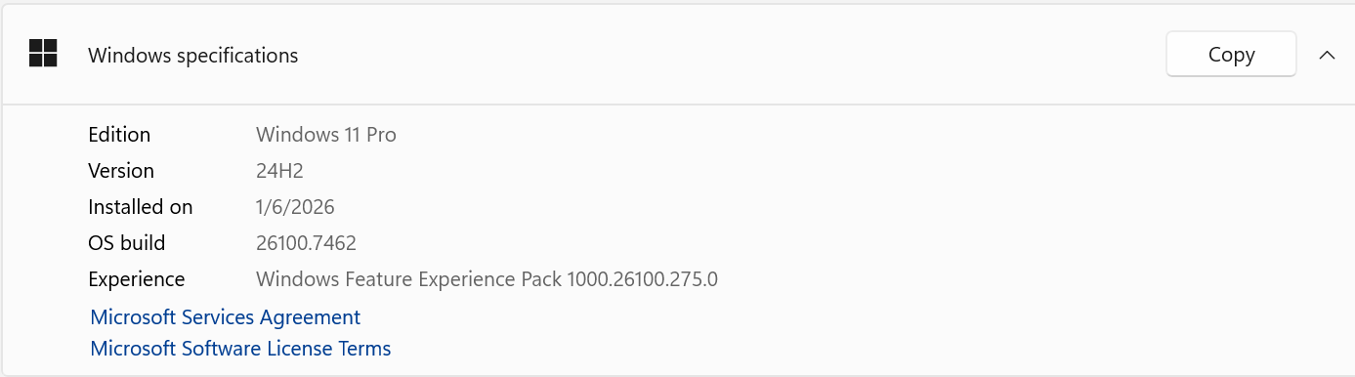
Operating System and Development Environment
The backend was developed in a Windows environment (Compatible with YARA and easier deployment to cloud). Python 3.12 was used as the primary programming language for the backend. The development environment included VS Code for editing the application code, model development and testing. Version control was done with Git.
Backend Framework
FastAPI was chosen for backend (a modern Python web framework) used to implement the RESTful API server for the detection system. FastAPI was selected for its speed and ease of integrating Python logic (particularly machine learning models) into web endpoints (Wu, 2024). The backend exposes endpoints for image upload and scanning, making it straightforward for a frontend or other clients to submit files and receive results.
Machine Learning Libraries
Scikit-learn was used to implement the Machine Learning specifically for the IsolationForest and RandomForest implementations. Data processing utilized libraries like NumPy and pandas for handling feature vectors, and SciPy for any statistical calculations needed (e.g., entropy). Pillow (PIL) library was used for image reading and basic image processing tasks (like resizing or accessing pixel data), and joblib
YARA Integration
YARA was integrated using the yara-python library (version 4.x). Yara-python allows compiling rules and scanning files directly from Python code. The same YARA rules file (stego_rules.yar) written was loaded by the backend on startup. The YARA engine runs in-process for each file scan, which is efficient given the small file sizes (images a few MB at most). YARA library was installed and updated in the running environment to support rule syntax (some rules used latest YARA features).
Frontend
For the user interface, a simple web frontend was developed to allow users to upload images and view results. The frontend was built as a single-page application using HTML5/JavaScript, with a heavy use of React framework for ease of creating a responsive UI. The frontend provides an upload option for images, option to embed a payload (manually or auto generated), options to select scanning mode (YARA, ML, or hybrid), and displays the scan results. Styling was done with vanilla CSS for a clean look. The choice of a web UI was to simulate an end-user tool or a dashboard an analyst might use. Alternatively, the API can be used directly via command-line or scripts (Which was tested via cURL during development as well).
Cloud Deployment
The backend was deployed using Docker containers to ensure consistency between development and production. A Dockerfile was written to containerize the FastAPI app along with the YARA rules and ML model. The container image was then deployed to Google Cloud Run, a serverless container service on GCP (Google Cloud Platform). Cloud Run was chosen for its simplicity in deploying containerized web services and automatic scaling capabilities. The backend was thus accessible via a secure HTTPS endpoint provided by Cloud Run. The FastAPI app, running inside the container, listens for requests (image uploads) and processes them as described. We configured environment variables on Cloud Run for things like the VirusTotal API key (so it’s not hardcoded).
(Place screenshot of Cloud Run URL + CORS test here)
Frontend Hosting
The frontend (static files for the React app) was hosted using Firebase Hosting. Firebase Hosting offers global CDN and easy deployment for static sites. The front-end build was uploaded using the Firebase CLI (firebase init and firebase deploy). The frontend is then accessible via a Firebase-provided web URL (or a custom domain if configured). It communicates with the backend’s Cloud Run endpoint via REST calls. The CORS configuration on the FastAPI side were handled to allow the Firebase domain to make requests.
(Place screenshot of Firebase Hosting deploy output here)
Storage and Database
The implemented system uses Firebase Storage and Cloud Firestore as integral parts of the steganographic malware detection workflow. All images processed by the system both original (benign) and stego (malicious) are stored in Firebase Storage, while Firestore is used to persist structured metadata and detection results. Each image uploaded into a scan workspace is registered in Firestore with fields such as filename, type (original or stego), true label, and a storagePath reference to the corresponding object in Storage. Detection stages (YARA, anomaly detection, hybrid fusion, metrics, and VirusTotal benchmarking) operate by downloading image bytes directly from Firebase Storage into memory and recording their outputs back into Firestore collections linked to the scan.
This persistent storage design is required for steganography research, as it enables repeatable analysis, separation of datasets, and post-scan evaluation. Firestore collections store YARA matches, anomaly predictions, hybrid decisions, and evaluation metrics, allowing results to be reviewed, fused, and benchmarked without re-running earlier stages. Authentication and scan ownership checks ensure that stored images and results are isolated per user and scan workspace. The use of Firebase Storage and Firestore therefore supports controlled experimentation and traceability while avoiding local disk dependencies in the backend execution environment.
APIs and Keys:
For the VirusTotal integration, the API was acquired (public API) and stored securely as an environment variable on Cloud Run, not in code. The system uses the VT API to hash the image and do a hash lookup (to check if known malicious) or to submit the file for scanning. The system follows the API rate limits by testing a small number of samples.
In summary, the system implementation environment consisted of a Python-based FastAPI backend containerized and running on GCP, a React/JavaScript frontend served via Firebase, and the necessary libraries (YARA, scikit-learn, etc.) for detection logic. This stack was chosen to mimic a realistic deployment scenario: a cloud-hosted scanning service with a web interface. The use of containerization ensures the system can be easily replicated or deployed on other platforms as needed.
[Insert Diagram: System Architecture]
illustrates the relationships between these components:
The user interacts with the web frontend, which sends the image to the FastAPI backend on Cloud Run; the backend uses YARA (via yara-python) and the ML model (via scikit-learn) to analyse the image, possibly consulting VirusTotal, and returns the result to the user interface.

4.3 Steganographic Sample Generation
The implementation of the detection system required the availability of a controlled and traceable dataset consisting of two distinct categories of images: original (benign) images and stego (malicious) images. These images are generated and managed within the same scan workspace, ensuring that each stego image can be directly linked back to its original source image. This linkage is essential for evaluation, ground-truth labelling, and later performance analysis, as described in Chapter 3.
Steganographic samples are generated inside the system itself using a backend API endpoint. The generation process is initiated through the endpoint POST /embed, which operates on images already uploaded to a scan and marked with type="original". For each original image, a steganographic payload is embedded using Least Significant Bit (LSB) substitution, and the resulting image is stored as a new file in Firebase Storage. A corresponding Firestore document is created to register the stego image, explicitly labelling it with type="stego" and true_label=1.
The implemented system does not support file append techniques, PNG chunk manipulation, or EXIF/metadata injection. These techniques are intentionally excluded from the operational prototype and are not present in the backend or frontend code. Only LSB-based embedding is implemented and documented in this chapter.
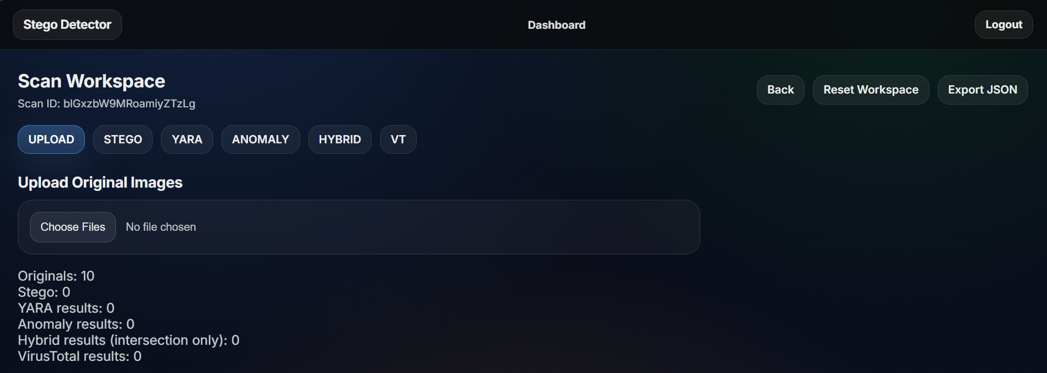
(Place screenshot of the scan workspace showing original images loaded here)
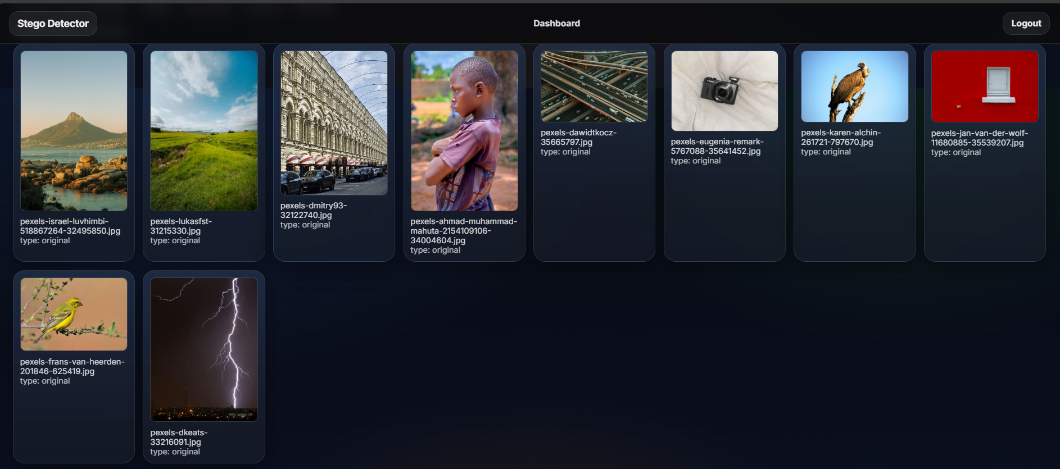
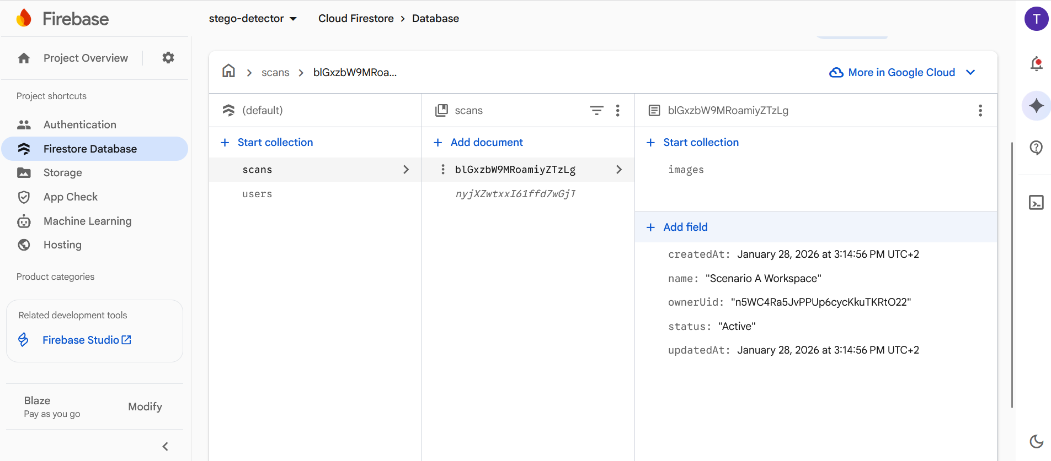
(Place screenshot of Firestore images collection showing type="original" entries here)
4.3.1 LSB Substitution
The steganographic embedding mechanism implemented in the system uses Least Significant Bit substitution applied to RGB images. In this approach, payload data is embedded by replacing the least significant bit of each colour channel value (red, green, and blue) with bits from the payload. This method is widely used in image steganography due to its simplicity and its minimal impact on perceptual image quality.
The system supports two payload generation modes, selectable through the frontend interface:
- Random payload generation, where cryptographically secure random bytes are generated using os.urandom
- User-defined payload embedding, where user-provided text is converted into bytes using either UTF-8 encoding or Base64 decoding
Each generated stego image includes detailed payload metadata stored in Firestore. This metadata enables traceability and verification during evaluation. The stored fields include:
1. payload_mode
2. payload_encoding
3. payload_len
4. payload_sha256
5. payload_preview_base64
6. parentImageId
7. sha256
8. true_label = 1
9. type = "stego"
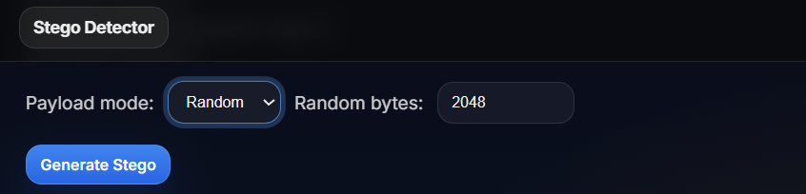
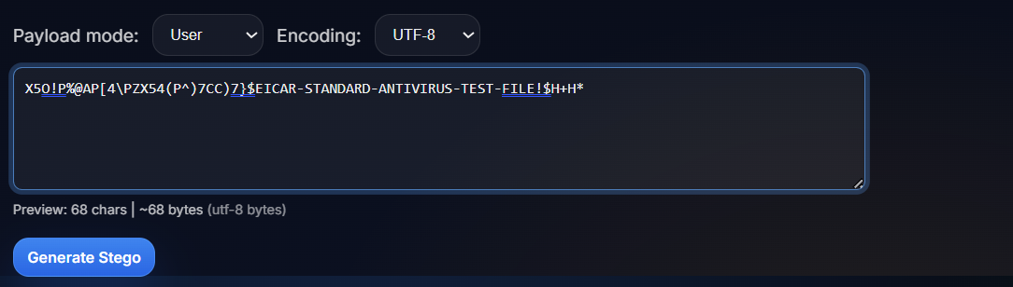
(Place screenshot of the embedding UI showing payload mode and encoding options here)
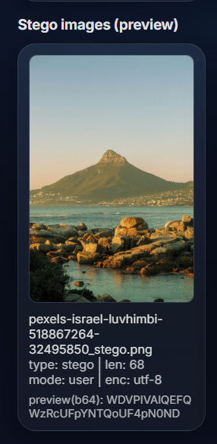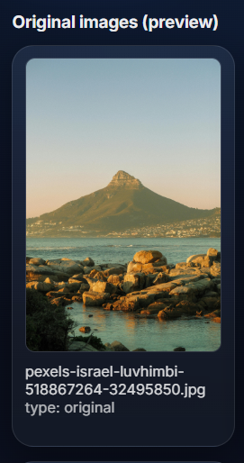
(Place screenshot of an original image next to its LSB stego image here)
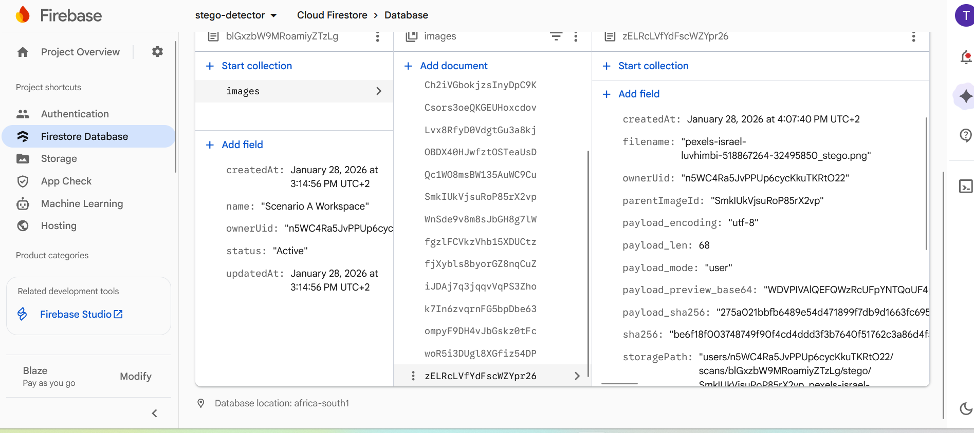
(Place screenshot of a Firestore stego image document showing payload_* fields here)
4.3.1.1 Payload Creation Logic
Payload creation is handled entirely in the backend by the function _payload_from_req(...). This function is responsible for validating user input, generating payload bytes, and constructing a metadata dictionary that is later stored alongside the stego image.
The function distinguishes explicitly between random payloads and user-supplied payloads. No implicit or default payload generation is performed.
1. def _payload_from_req(req: EmbedReq) -> Tuple[bytes, Dict[str, Any]]:
2. if req.payload_mode == "random":
3. payload = os.urandom(int(req.payload_size))
4. meta = {
5. "payload_mode": "random",
6. "payload_encoding": "bytes",
7. "payload_len": int(len(payload)),
8. "payload_sha256": sha256(payload),
9. "payload_preview_base64": base64.b64encode(
10. payload[:PAYLOAD_PREVIEW_BYTES]
11. ).decode("ascii"),
12. }
13. return payload, meta
14.
15. if not req.payload_text or not req.payload_text.strip():
16. raise HTTPException(400, "payload_text is required when payload_mode='user'")
17.
18. if req.payload_encoding == "base64":
19. try:
20. payload = base64.b64decode(req.payload_text.strip(), validate=True)
21. except Exception:
22. raise HTTPException(400, "Invalid base64 payload_text")
23. enc = "base64"
24. else:
25. payload = req.payload_text.encode("utf-8")
26. enc = "utf-8"
27.
28. if len(payload) < 1:
29. raise HTTPException(400, "payload_text is empty")
30. if len(payload) > MAX_PAYLOAD_BYTES:
31. raise HTTPException(400, f"payload too large (max {MAX_PAYLOAD_BYTES} bytes)")
32.
33. meta = {
34. "payload_mode": "user",
35. "payload_encoding": enc,
36. "payload_len": int(len(payload)),
37. "payload_sha256": sha256(payload),
38. "payload_preview_base64": base64.b64encode(
39. payload[:PAYLOAD_PREVIEW_BYTES]
40. ).decode("ascii"),
41. }
42. return payload, meta
43.
This logic ensures:
- Payloads are always explicitly defined
- Invalid Base64 input is rejected
- Oversized payloads are blocked
- Metadata is always available for downstream analysis
(Place screenshot of the UI showing “Random” vs “User” payload selection here)
(Place screenshot of an error message for invalid Base64 or oversized payload here)
4.3.1.2 LSB Embedding Logic
After payload creation, the system embeds the payload into an image using the function _embed_lsb(...). This function performs a precise and deterministic sequence of operations.
The embedding process begins by converting the input image to RGB format to ensure consistent channel handling. The payload is then prefixed with a 4-byte big-endian length header, which allows the embedded data to be delimited correctly. The combined byte sequence is converted into a bitstream, processed from most significant bit to least significant bit.
Before embedding, the function calculates the embedding capacity of the image as:
1. capacity_bits = number_of_pixels × 3
If the payload exceeds the available capacity, the function raises an exception and aborts the embedding process.
1. def _embed_lsb(img: Image.Image, payload: bytes) -> Image.Image:
2. img = img.convert("RGB")
3. pixels = list(img.getdata())
4.
5. full = len(payload).to_bytes(4, "big") + payload
6.
7. bits: List[int] = []
8. for b in full:
9. bits.extend([(b >> i) & 1 for i in range(7, -1, -1)])
10.
11. capacity_bits = len(pixels) * 3
12. if len(bits) > capacity_bits:
13. raise ValueError(f"Payload too big for image capacity ({len(bits)} > {capacity_bits})")
14.
15. out_pixels = []
16. idx = 0
17. for r, g, b in pixels:
18. if idx < len(bits):
19. r = (r & 0xFE) | bits[idx]; idx += 1
20. if idx < len(bits):
21. g = (g & 0xFE) | bits[idx]; idx += 1
22. if idx < len(bits):
23. b = (b & 0xFE) | bits[idx]; idx += 1
24. out_pixels.append((r, g, b))
25.
26. out = Image.new("RGB", img.size)
27. out.putdata(out_pixels)
28. return out
Only one least significant bit per channel is modified. No higher-order bits are altered, ensuring minimal visual distortion. The output image is always saved as PNG to prevent lossy compression from destroying embedded data.
(Place screenshot of this function in the code editor here)
4.3.1.3 Bulk Stego Sample Generation via API
Stego image generation is performed in bulk through the backend endpoint POST /embed. When this endpoint is invoked, the backend iterates over all images in the scan marked as type="original".
For each original image, the backend:
- Downloads the image bytes from Firebase Storage
- Generates payload bytes and metadata
- Applies LSB embedding
- Saves the resulting stego image as a new PNG file in Firebase Storage
- Creates a Firestore document registering the stego image and its metadata
This process ensures that each stego image remains directly linked to its original source image within the same scan workspace.
(Place screenshot of the /embed request payload in browser developer tools here)
(Place screenshot of Firebase Storage showing stego images under users/<uid>/scans/<scanId>/stego/ here)
4.3.2 File Append and Metadata Injection
File append techniques (such as appending payloads after PNG IEND or JPEG EOI markers), PNG chunk manipulation, and EXIF metadata injection are not implemented in the system. These techniques are excluded from the backend and frontend codebase and are not used during sample generation for this implementation chapter.
Such techniques may be considered for future experimental work or offline dataset generation, but they are not part of the operational prototype described here.
(Place screenshot here indicating “Future Work: File Append / Metadata Injection”)

4.4 YARA Rule Implementation
The YARA rules described in Chapter 3 were implemented as the signature-based detection stage of the backend system. YARA is used to scan raw image byte streams in order to detect known signatures and recognizable byte-pattern indicators that may suggest the presence of embedded malicious content. The system does not attempt to execute or unpack malware; instead, it relies on static byte-level inspection of image files.
All YARA rules are stored in a plain-text ruleset file named stego_rules.yar, which is included in the backend application and packaged into the Docker image at build time. During execution, the backend compiles these rules and applies them to images retrieved from Firebase Storage. In addition to the default ruleset, the system supports per-scan custom YARA rule uploads, allowing different rule configurations to be tested within individual scan workspaces without modifying or redeploying the backend.
(Place screenshot of stego_rules.yar opened in VS Code here)
(Place screenshot of the Scan page showing the “Upload YARA Rules” option here)
4.4.1 Rule File Structure (stego_rules.yar)
The YARA rules file is implemented as a standard YARA ruleset and does not rely on external YARA modules such as the PE module. This decision was made because the detection task focuses on images as carrier files, not executable formats. The rules therefore operate entirely on raw byte sequences rather than structured executable parsing.
Each rule in the file follows standard YARA syntax, consisting of A rule name, A metadata section describing the rule, A strings section defining byte or ASCII patterns and a condition section defining when a match occurs. An example of a rule present in the system is shown below:
1. rule Embedded_EICAR_Payload
2. {
3. meta:
4. description = "Detects EICAR test string embedded in image bytes"
5. author = "Thesis"
6. version = "1.0"
7.
8. strings:
9. $m = "X5O!P%@AP[4\\PZX54(P^)7CC)7}$EICAR-STANDARD-ANTIVIRUS-TEST-FILE!$H+H*" ascii
10.
11. condition:
12. $m
13. }
This rule defines a single ASCII string corresponding to the full EICAR anti-virus test signature. The condition specifies that the rule should match if this string appears anywhere in the scanned file. The rule is intentionally simple and serves multiple purposes such as validating that the YARA engine is functioning correctly within the system, detecting cases where payloads are appended directly to image files in plaintext and providing a clear baseline example for rule testing and verification.
If the EICAR string is embedded using LSB bit-splitting, the string does not exist contiguously in the file’s byte stream, and therefore the rule does not match. This behaviour is expected and aligns with the design of the detection pipeline.
(Place screenshot of YARA results showing this rule firing for a plaintext/appended payload here)
(Place screenshot of YARA results showing no match for an LSB-embedded payload here)
    - Rule Authoring and Compilation Errors
During rule development, syntax errors were encountered while editing the ruleset. These errors typically arose from missing closing braces, unbalanced quotation marks, incomplete condition expressions or files ending unexpectedly without proper termination. These errors prevent the ruleset from being compiled and therefore block scanning until corrected. These issues were resolved by carefully reviewing rule formatting and ensuring that each rule block is syntactically complete.
(Place screenshot of an invalid YARA rules error message in the UI here)
(Place screenshot of corrected rules successfully compiling here)
4.4.3 Rules Compilation and Selection Strategy
YARA rules are compiled per scan, rather than once globally at application startup. This design enables different scans to use different rule sets without interference. The backend determines which rules to compile using the following logic:
- If a scan has a custom rules file associated with it, that file is downloaded and compiled.
- If no custom rules are present, the default stego_rules.yar file on disk is compiled.
The compilation logic is implemented as follows:
1. def _compile_yara_rules_for_scan(scan_id: str) -> yara.Rules:
2. """
3. Prefer per-scan uploaded rules. Fall back to RULES_PATH on disk.
4. """
5. custom = _scan_custom_yara_path(scan_id)
6. if custom:
7. b = download_bytes(custom)
8. try:
9. return yara.compile(source=b.decode("utf-8"))
10. except Exception as e:
11. raise HTTPException(400, f"Uploaded YARA rules invalid: {str(e)}")
12.
13. if not os.path.exists(RULES_PATH):
14. raise HTTPException(500, f"Rules missing: {RULES_PATH}")
15. return yara.compile(filepath=RULES_PATH)
This approach allows for an isolation of experimental rules within a single scan, provides immediate feedback on invalid rule uploads and offer a stable use of the default ruleset for normal operation.
(Place screenshot of Firestore scan document showing yaraRulesPath here)
4.4.4 Custom YARA Rule Upload
The system includes an endpoint that allows a user to upload a custom YARA rules file for a specific scan. When a rules file is uploaded, the backend:
- Validates the file extension (.yar or .yara)
- Attempts to compile the rules immediately
- Rejects the upload if compilation fails
- Stores the rules file in Firebase Storage
- Saves the storage path in the scan document
This workflow enables rapid experimentation with alternative rulesets while preserving the default detection configuration.
(Place screenshot of YARA rules upload UI here)
(Place screenshot of Firebase Storage showing the uploaded rules file here)
4.4.5 YARA Scanning Integration
Images are scanned in memory without being written to disk. Each image’s byte stream is downloaded directly from Firebase Storage and passed to the YARA engine. The scanning process uses YARA’s match(data=...) interface, which operates on byte buffers:
1. b = download_bytes(img["storagePath"])
2. matches = rules.match(data=b)
3. hit = 1 if matches else 0
This approach avoids unnecessary disk I/O and aligns with the existing feature-extraction workflow, which also operates on in-memory data.
4.4.5.1 YARA Scan Execution Flow
When a YARA scan is initiated from the frontend, the backend performs the following steps:
- Compile the appropriate YARA rules for the scan
- Select images based on the requested target type (original, stego, or all)
- Download image bytes from storage
- Apply YARA matching to each image
- Store the results in Firestore
For each image, the following data is recorded:
- yara_detected (0 or 1)
- matched_rules (semicolon-separated rule names)
- scanned_as (original or stego)
- Timestamps
(Place screenshot of the YARA scan request payload in browser Network tab here)
(Place screenshot of Firestore yara_results collection here)
4.4.6 Implemented Rule Coverage
The rules currently present in the system focus on detecting known plaintext signatures embedded within image files. At present, the ruleset includes:
- Embedded_EICAR_Payload
Additional rule concepts such as PE header detection or entropy-based heuristics are not present in the current rules file and are therefore excluded from this section. Such rules may be added later as extensions, but they are not part of the implemented system described here.
(Place screenshot of the full contents of stego_rules.yar here)
4.4.7 Testing and Validation
Testing of the YARA integration followed the full system workflow:
- Upload benign images as originals
- Generate stego images using the embedding functionality
- Execute YARA scanning on selected image subsets
Observed behaviour included:
- Plaintext/appended payloads triggering rule matches
- LSB-embedded payloads not triggering matches
- Benign images producing no matches
These outcomes aligned with the intended design of the signature-based detection stage.
(Place screenshot of benign images with no YARA detections here)
(Place screenshot of detected image with matched rule name here)
4.4.8 Performance Considerations and rule maintenance
YARA scanning operates efficiently due to the limited number of rules and the use of simple byte-pattern matching. Scanning overhead is minimal compared to feature extraction and anomaly detection. Results are stored persistently, allowing subsequent processing stages to reuse detection outcomes without repeating scans.
(Place screenshot of backend logs showing YARA scan execution here)
Rule maintenance is supported through:
- A default bundled ruleset (stego_rules.yar)
- Per-scan custom rule uploads
This design supports ongoing experimentation and future rule updates without altering the core system architecture.
(Place screenshot of scan workspace showing an associated YARA rules file here)

4.5 Machine Learning Model Implementation
The machine learning component of the system was implemented in the backend using Python and the scikit-learn library. The purpose of this component is to identify anomalous images that deviate from the statistical characteristics of benign images, particularly in cases where signature-based detection does not trigger. The implemented system uses an Isolation Forest anomaly detection model as the sole machine learning model in the operational pipeline. Although earlier experimental work considered supervised classifiers such as Random Forest for comparison, the deployed system relies exclusively on unsupervised anomaly detection.
The machine learning workflow consists of feature extraction, model training, threshold calibration, and per-image inference, all of which are executed within the backend application.
(Place screenshot of the “Anomaly” tab in the Scan page here)
4.5.1 Model Training Approach
Model training is performed dynamically when anomaly detection is requested. The system does not rely on a pre-trained static model loaded at startup. Instead, the backend trains an Isolation Forest model using images selected from the current scan workspace.
The user specifies, via the frontend interface, which subset of images should be used for training and which subset should be evaluated. The training options include:
- Training on original (benign) images
- Training on stego images (for experimental analysis)
This configuration allows controlled experiments within the same scan without modifying the application code or redeploying the backend.
(Place screenshot of the Anomaly configuration controls showing “train_on” and “test_on” options here)
4.5.2 Feature Extraction
Feature extraction is implemented directly in the backend and operates on raw image bytes retrieved from Firebase Storage. There is no separate feature extraction module; the logic resides within the main backend application file. The system extracts a fixed-length numerical feature vector from each image. The features are designed to capture file-level and pixel-level statistical properties that may change when data is hidden inside an image.
Feature Order Definition
The backend defines a fixed feature order to ensure consistency between training and inference:
1. FEATURE_ORDER = [
2. "file_size_bytes",
3. "width",
4. "height",
5. "byte_entropy",
6. "r_mean",
7. "r_var",
8. "g_mean",
9. "g_var",
10. "b_mean",
11. "b_var",
12. ]
(Place screenshot of this feature order definition in the code editor here)
Feature Extraction Function
The feature extraction function processes raw image bytes and computes the defined feature set:
1. def extract_features(img_bytes: bytes) -> Dict[str, float]:
2. pil = Image.open(io.BytesIO(img_bytes)).convert("RGB")
3. arr = np.array(pil, dtype=np.uint8)
4.
5. counts = np.bincount(np.frombuffer(img_bytes, dtype=np.uint8), minlength=256)
6. probs = counts[counts > 0] / len(img_bytes)
7. entropy = -np.sum(probs * np.log2(probs))
8.
9. return {
10. "file_size_bytes": float(len(img_bytes)),
11. "width": float(pil.size[0]),
12. "height": float(pil.size[1]),
13. "byte_entropy": float(entropy),
14. "r_mean": float(np.mean(arr[:, :, 0])),
15. "r_var": float(np.var(arr[:, :, 0])),
16. "g_mean": float(np.mean(arr[:, :, 1])),
17. "g_var": float(np.var(arr[:, :, 1])),
18. "b_mean": float(np.mean(arr[:, :, 2])),
19. "b_var": float(np.var(arr[:, :, 2])),
20. }
The extracted features include the total file size in bytes, image width and height, Shannon entropy of the raw byte stream, mean and variance of pixel intensities for each RGB channel. These features are lightweight to compute and provide sensitivity to subtle statistical distortions introduced by steganographic embedding.
(Place screenshot of this function in the backend source code here)
4.5.3 Feature Vector Construction
For each image selected during training or evaluation, the backend:
- Downloads the image bytes from Firebase Storage.
- Passes the byte stream to the feature extraction function.
- Reorders the resulting dictionary according to FEATURE_ORDER.
- Appends the resulting numeric vector to the feature matrix.
This process produces a two-dimensional feature matrix suitable for machine learning input.
(Place screenshot of backend logs showing feature extraction for multiple images here)
4.5.4 Isolation Forest Training and Threshold Calibration
After feature extraction, the system trains an Isolation Forest model. Before training, features are normalized using StandardScaler to ensure that all features contribute proportionally to distance-based calculations.
The training process includes both model fitting and threshold calibration:
1. scaler = StandardScaler()
2. Xs_train = scaler.fit_transform(X_train)
3.
4. model = IsolationForest(
5. n_estimators=200,
6. contamination=contamination,
7. random_state=RNG_SEED,
8. ).fit(Xs_train)
9.
10. raw_val = model.decision_function(scaler.transform(X_val))
11. score_val = -raw_val
12. threshold = float(np.quantile(score_val, val_quantile))
13.
The decision function output of the Isolation Forest is inverted so that larger values correspond to greater anomaly. A threshold is then derived using a quantile of validation scores, allowing explicit control over sensitivity.
(Place screenshot of backend console output showing model training and threshold calculation here)
4.5.5 Model Persistence
After training, both the Isolation Forest model and the fitted scaler are saved to disk using joblib. This allows the trained model to be reused during the remainder of the scan session and ensures reproducibility of results.
1. joblib.dump(model, model_path)
2. joblib.dump(scaler, scaler_path)
(Place screenshot of the models/ directory showing saved model and scaler files here)
4.5.6 Anomaly Inference
During evaluation, each image’s feature vector is scaled and passed through the trained Isolation Forest model. The anomaly score and binary detection decision are computed as follows:
1. raw = model.decision_function(scaler.transform(vec))[0]
2. score = -float(raw)
3. is_det = 1 if score >= threshold else 0
4.
- anomaly_score represents the degree of deviation from normal behaviour.
- ml_detected indicates whether the image is classified as anomalous.
Each result is written to the Firestore anomaly_results subcollection along with metadata describing the training and testing configuration:
1. a_col.document(mid).set({
2. "file": img.get("filename", ""),
3. "anomaly_score": score,
4. "ml_detected": is_det,
5. "threshold": float(threshold),
6. "trained_on": req.train_on,
7. "tested_on": req.test_on,
8. "createdAt": firestore.SERVER_TIMESTAMP
9. }, merge=True)
(Place screenshot of a Firestore anomaly_results document here)
4.5.7 Frontend Interaction
The frontend triggers anomaly detection through a dedicated action in the Scan interface. When the user initiates anomaly detection, the frontend sends a request to the backend containing:
- The scan identifier
- The selected training dataset
- The selected testing dataset
The frontend then displays the resulting anomaly scores and detection status per image.
(Place screenshot of the Scan page showing anomaly results in table form here)
4.5.8 Error Handling and Robustness
If an image cannot be decoded by the image processing library, the feature extraction process raises an exception and the request fails. This behaviour avoids silently masking corrupted or invalid inputs and prevents misleading results from being stored.
4.5.9 Role of Machine Learning in the Detection Pipeline
The anomaly detection component operates as a complementary layer to signature-based scanning. Images that evade YARA rules due to obfuscation or payload fragmentation may still exhibit abnormal statistical properties and be flagged by the Isolation Forest. The outputs of this component are later combined with signature-based results in the hybrid detection stage.
(Place screenshot showing an image detected by anomaly detection but not by YARA here)

4.6 Hybrid Detection System Integration
With both the signature stage (YARA) and the anomaly stage (machine learning) implemented, the system was integrated into a single scan workspace pipeline. Unlike a “single file upload → immediate scan” API style, this prototype is workspace-based: images are first uploaded into a scan workspace (Firestore + Firebase Storage), and then detection stages are executed against the stored workspace images using backend endpoints. This design supports repeatable experiments, clean separation between originals and generated stego samples, and exportable results (JSON export) without re-uploading files for every test.
(Place screenshot of the Scan Workspace page showing tabs: UPLOAD / STEGO / YARA / ANOMALY / HYBRID / VT here)
(Place screenshot of the Firestore structure: scans/{scanId}/images and scans/{scanId}/...results collections here)
4.6.1 Workspace-based pipeline (how data flows through the system)
The pipeline is driven from the frontend page Scan.jsx, which loads and displays the scan workspace and writes/reads results from Firestore in real time using listeners.
The system uses the following Firestore collections inside a scan workspace:
- scans/{scanId}/images (original and stego image documents)
- scans/{scanId}/yara_results
- scans/{scanId}/anomaly_results
- scans/{scanId}/hybrid_results
- scans/{scanId}/virustotal_results
- scans/{scanId}/metrics/latest (latest metrics snapshot)
In Scan.jsx, listeners are attached to these collections so the UI updates immediately when the backend writes results:
1. const unsubImages = onSnapshot(
2. query(
3. collection(db, "scans", scanId, "images"),
4. orderBy("createdAt", "desc")
5. ),
6. (snap) => {
7. const r = [];
8. snap.forEach((d) => r.push({ id: d.id, ...d.data() }));
9. setImages(r);
10. }
11. );
12.
13. const unsubYara = onSnapshot(
14. collection(db, "scans", scanId, "yara_results"),
15. (snap) => {
16. const r = [];
17. snap.forEach((d) => r.push({ id: d.id, ...d.data() }));
18. setYaraRows(r);
19. }
20. );
21.
22. const unsubAnom = onSnapshot(
23. collection(db, "scans", scanId, "anomaly_results"),
24. (snap) => {
25. const r = [];
26. snap.forEach((d) => r.push({ id: d.id, ...d.data() }));
27. setAnomRows(r);
28. }
29. );
30.
31. const unsubHybrid = onSnapshot(
32. collection(db, "scans", scanId, "hybrid_results"),
33. (snap) => {
34. const r = [];
35. snap.forEach((d) => r.push({ id: d.id, ...d.data() }));
36. setHybridRows(r);
37. }
38. );
39.
40. const unsubVT = onSnapshot(
41. collection(db, "scans", scanId, "virustotal_results"),
42. (snap) => {
43. const r = [];
44. snap.forEach((d) => r.push({ id: d.id, ...d.data() }));
45. setVtRows(r);
46. }
47. );
48.
49. const unsubMetrics = onSnapshot(
50. doc(db, "scans", scanId, "metrics", "latest"),
51. (snap) => {
52. setMetricsLatest(snap.exists() ? snap.data() : null);
53. }
54. );
This workspace architecture is important for hybrid detection because hybrid fusion is computed from stored YARA + ML results, not by scanning “live uploads”.
(Place screenshot of the Firestore images documents showing type: "original" and type: "stego" here)
(Place screenshot of the Firestore yara_results, anomaly_results, and hybrid_results collections populated after running scans here)
4.6.2 Authentication and secure backend invocation (API calls from the UI)
All backend pipeline endpoints require authentication. The frontend obtains the Firebase ID token and sends it as a Bearer token in every request.
Scan.jsx uses a shared helper for API calls:
1. async function apiCall(endpoint, body = null, method = "POST") {
2. if (!user) throw new Error("Not logged in.");
3.
4. let token = await getToken();
5. const opts = {
6. method,
7. headers: { Authorization: `Bearer ${token}` },
8. };
9. if (body) {
10. opts.body = JSON.stringify(body);
11. opts.headers["Content-Type"] = "application/json";
12. }
13.
14. let res;
15. try {
16. res = await fetch(`${API_BASE}${endpoint}`, opts);
17. } catch (e) {
18. // This is what you see as “Failed to fetch” (CORS/network).
19. throw new Error("Failed to fetch (check backend is running + CORS + URL).");
20. }
21.
22. if (res.status === 401) {
23. token = await user.getIdToken(true);
24. opts.headers.Authorization = `Bearer ${token}`;
25. res = await fetch(`${API_BASE}${endpoint}`, opts);
26. }
27.
28. if (!res.ok) {
29. const t = await res.text();
30. throw new Error(t || `Request failed (${res.status})`);
31. }
32.
33. // some endpoints may return empty
34. const txt = await res.text();
35. return txt ? JSON.parse(txt) : { ok: true };
36. }
37.
This is paired with backend-side verification and ownership enforcement. Every pipeline endpoint begins by validating the token and ensuring the scan belongs to the authenticated user:
1. uid = verify_user(authorization)
2. assert_scan_owner(uid, req.scanId)
(Place screenshot of a browser Network tab request showing Authorization: Bearer <token> here)
(Place screenshot of a 401 error case (if token expired) and the retry behaviour here)
4.6.3 Hybrid fusion execution (backend orchestration logic)
Hybrid detection is computed by combining previously stored YARA and ML outcomes in the same scan workspace. The backend endpoint responsible for hybrid fusion is:
1. @app.post("/hybrid")
2. def hybrid(req: HybridReq, authorization: Optional[str] = Header(None)):
3. uid = verify_user(authorization)
4. assert_scan_owner(uid, req.scanId)
5.
6. yara_map = _get_yara_map(req.scanId)
7. anom_map = _get_anom_map(req.scanId)
8.
9. out_col = db.collection("scans").document(req.scanId).collection("hybrid_results")
10. fusion = req.fusion.upper()
11.
12. # ✅ Fuse ONLY where we have BOTH YARA + ML (intersection)
13. yara_ids = set(yara_map.keys())
14. ml_ids = set(anom_map.keys())
15. fuse_ids = sorted(list(yara_ids.intersection(ml_ids)))
16.
17. if not fuse_ids:
18. raise HTTPException(400, "No intersection of YARA and ML results. Run YARA and Anomaly on the same target set.")
19.
20. total = 0
21. detected = 0
22.
23. for mid in fuse_ids:
24. img_doc = db.collection("scans").document(req.scanId).collection("images").document(mid).get()
25. if not img_doc.exists:
26. continue
27. img = img_doc.to_dict() or {}
28.
29. y = yara_map.get(mid) or {}
30. a = anom_map.get(mid) or {}
31.
32. yara_hit = int(y.get("yara_detected", 0) or 0)
33. ml_hit = int(a.get("ml_detected", 0) or 0)
34.
35. final_pred = int(_apply_fusion(fusion, yara_hit, ml_hit))
36. source = "BOTH" if (yara_hit and ml_hit) else ("YARA" if yara_hit else ("ML" if ml_hit else "NONE"))
37.
38. out_col.document(mid).set({
39. "file": img.get("filename", ""),
40. "fusion": fusion,
41. "yara_detected": yara_hit,
42. "ml_detected": ml_hit,
43. "final_pred": final_pred,
44. "decision_source": source,
45. "missing_yara": False,
46. "missing_ml": False,
47. "createdAt": firestore.SERVER_TIMESTAMP,
48. }, merge=True)
49.
50. total += 1
51. detected += 1 if final_pred == 1 else 0
52.
53. return {"ok": True, "evaluated": total, "hybrid_detected": detected, "fusion": fusion}
54.
Key orchestration behaviour implemented here:
- Hybrid does not rescan images. It reads yara_results and anomaly_results using _get_yara_map(...) and _get_anom_map(...).
- Hybrid is computed only on the intersection of IDs present in both result sets:
  - fuse_ids = yara_ids.intersection(ml_ids)
  - This prevents silent defaults and ensures the hybrid output is computed only when both stages actually ran on the same image IDs.
- The final prediction is written to scans/{scanId}/hybrid_results/{imageId} with:
  - yara_detected, ml_detected, final_pred
  - decision_source indicating whether the decision came from BOTH / YARA / ML / NONE
  - fusion storing OR/AND choice from the request
(Place screenshot of the Firestore hybrid_results document showing fields: fusion, yara_detected, ml_detected, final_pred, decision_source here)
(Place screenshot of the UI HYBRID tab table populated after running hybrid here)
4.6.4 Hybrid controls and intersection enforcement (frontend behaviour)
The Scan workspace UI explicitly enforces that hybrid can only run after both YARA and ML have produced results.
This is implemented in Scan.jsx:
1. // backend now errors if there is no intersection, so require BOTH
2. const canRunHybrid = yaraRows.length > 0 && anomRows.length > 0 && !busy.active && !!user;
3. Additionally, the UI notes the hybrid behaviour as “intersection-only”:
4. // NEW hybrid model: backend writes only intersection rows (IDs that have BOTH YARA + ML)
5. const hybridDetected = useMemo(
6. () => hybridRows.filter((x) => Number(x.final_pred) === 1),
7. [hybridRows]
8. );
9.
This prevents a situation where hybrid results appear for images that were not evaluated by both detection stages.
(Place screenshot of the HYBRID tab controls (fusion selection OR/AND) here)
(Place screenshot of the error message returned when hybrid is run without intersection here)
4.6.5 VirusTotal integration (external benchmarking tied to anomaly results)
VirusTotal benchmarking is integrated as a separate stage that operates on the scan workspace and writes results back to Firestore.
The VirusTotal submission endpoint:
1. @app.post("/virustotal")
2. def virustotal_submit(req: VTSubmitReq, authorization: Optional[str] = Header(None)):
3. uid = verify_user(authorization)
4. assert_scan_owner(uid, req.scanId)
5.
6. if not VT_API_KEY:
7. raise HTTPException(500, "VT_API_KEY missing")
8.
9. # choose target items from anomaly_results
10. target_val = 0 if req.mode == "undetected" else 1
11. anom = (
12. db.collection("scans").document(req.scanId)
13. .collection("anomaly_results")
14. .where("ml_detected", "==", target_val)
15. .stream()
16. )
17. ids = [d.id for d in anom]
18. if not ids:
19. raise HTTPException(400, "No target images found (based on anomaly_results).")
20.
21. vt_col = db.collection("scans").document(req.scanId).collection("virustotal_results")
22. submitted = 0
23.
24. for mid in ids:
25. img_doc = db.collection("scans").document(req.scanId).collection("images").document(mid).get()
26. if not img_doc.exists:
27. continue
28. img = img_doc.to_dict() or {}
29. b = download_bytes(img["storagePath"])
30.
31. try:
32. h = {"x-apikey": VT_API_KEY}
33. r1 = requests.post(
34. "https://www.virustotal.com/api/v3/files",
35. headers=h,
36. files={"file": (img.get("filename", "file.bin"), b)}
37. )
38. if r1.status_code >= 300:
39. vt_col.document(mid).set({
40. "file": img.get("filename", ""),
41. "status": "failed",
42. "error": r1.text,
43. "createdAt": firestore.SERVER_TIMESTAMP
44. }, merge=True)
45. continue
46.
47. aid = r1.json()["data"]["id"]
48.
49. # store as queued; refresh endpoint completes later
50. vt_col.document(mid).set({
51. "file": img.get("filename", ""),
52. "status": "queued",
53. "analysisId": aid,
54. "detections": None,
55. "engines": None,
56. "results": None,
57. "createdAt": firestore.SERVER_TIMESTAMP
58. }, merge=True)
59.
60. submitted += 1
61.
62. except Exception as e:
63. vt_col.document(mid).set({
64. "file": img.get("filename", ""),
65. "status": "failed",
66. "error": str(e),
67. "createdAt": firestore.SERVER_TIMESTAMP
68. }, merge=True)
69.
70. return {"ok": True, "submitted": submitted, "mode": req.mode}
This implementation has two important constraints:
- Targets for VirusTotal are chosen from anomaly_results, not from images directly.
The endpoint queries:
- .collection("anomaly_results").where("ml_detected", "==", target_val)
meaning VirusTotal comparison is intentionally linked to anomaly outcomes (for example, submitting “detected” or “undetected” subsets).
- VirusTotal results are queued first, then finalized later by a refresh endpoint. This prevents blocking on analysis completion.
The refresh endpoint is:
1. @app.post("/virustotal/refresh")
2. def virustotal_refresh(req: VTRefreshReq, authorization: Optional[str] = Header(None)):
3. uid = verify_user(authorization)
4. assert_scan_owner(uid, req.scanId)
5.
6. if not VT_API_KEY:
7. raise HTTPException(500, "VT_API_KEY missing")
8.
9. vt_col = db.collection("scans").document(req.scanId).collection("virustotal_results")
10.
11. # Pull docs
12. docs = list(vt_col.stream())
13. rows = []
14. for d in docs:
15. row = d.to_dict() or {}
16. if req.only_status == "queued" and row.get("status") != "queued":
17. continue
18. if not row.get("analysisId"):
19. continue
20. rows.append((d.id, row))
21.
22. rows = rows[: max(1, min(req.max_items, 100))]
23. updated = 0
24.
25. h = {"x-apikey": VT_API_KEY}
26. for mid, row in rows:
27. aid = row["analysisId"]
28. r2 = requests.get(f"https://www.virustotal.com/api/v3/analyses/{aid}", headers=h)
29. if r2.status_code >= 300:
30. continue
31.
32. d2 = (r2.json().get("data", {}) or {}).get("attributes", {}) or {}
33. status = d2.get("status", "queued")
34.
35. results = d2.get("results", {}) or {}
36. stats = d2.get("stats", {}) or {}
37.
38. if status != "completed":
39. # still queued
40. vt_col.document(mid).set({"status": status}, merge=True)
41. updated += 1
42. continue
43.
44. simple_res = {k: (v or {}).get("category", "undetected") for k, v in results.items()}
45. vt_col.document(mid).set({
46. "status": "completed",
47. "detections": int(stats.get("malicious", 0) + stats.get("suspicious", 0)),
48. "engines": int(sum(stats.values())) if stats else 0,
49. "results": simple_res,
50. "createdAt": firestore.SERVER_TIMESTAMP
51. }, merge=True)
52. updated += 1
53.
54. return {"ok": True, "checked": len(rows), "updated": updated}
55.
The refresh stage updates:
- status from queued → completed
- detections, engines
- results (simplified per-engine categories)
(Place screenshot of Firestore virustotal_results showing status=queued and analysisId here)
(Place screenshot of Firestore virustotal_results showing status=completed with detections/engines here)
(Place screenshot of the VT tab showing the queued vs completed results here)
4.6.6 Metrics and evaluation integration (hybrid evaluation tied to stored results)
The system computes evaluation metrics only from results that actually exist in Firestore (no silent default predictions). The metrics endpoint begins by loading maps for YARA, ML, and Hybrid:
1. yara_map = _get_yara_map(req.scanId)
2. anom_map = _get_anom_map(req.scanId)
3. hyb_map = {d.id: (d.to_dict() or {}) for d in db.collection("scans").document(req.scanId).collection("hybrid_results").stream()}
It then builds evaluated sets per method using only images with recorded outputs (for example: if an image has no yara_results row, it is skipped for YARA metrics). This preserves correctness when hybrid is intersection-based and prevents inflated metrics from accidental assumptions.
(Place screenshot of the METRICS section in the UI showing evaluated_counts and metrics here)
(Place screenshot of the Firestore metrics/latest document here)
4.6.7 Workspace reset and reproducible experiments
To support repeated experiments in a clean and controlled way, the backend includes a workspace reset endpoint that removes stego images and all results while keeping original images.
The frontend calls:
1. // backend: POST /scan/{scan_id}/reset
2. await apiCall(`/scan/${scanId}/reset`, null, "POST");
3. The backend performs the reset:
4. @app.post("/scan/{scan_id}/reset")
5. def reset_scan(scan_id: str, authorization: Optional[str] = Header(None)):
6. uid = verify_user(authorization)
7. ref = assert_scan_owner(uid, scan_id)
8.
9. # 1) Delete all non-original image docs + their blobs (stego etc.)
10. img_col = ref.collection("images")
11. all_imgs = list(img_col.stream())
12.
13. for d in all_imgs:
14. data = d.to_dict() or {}
15. t = (data.get("type") or "").lower()
16. if t == "original":
17. continue
18.
19. sp = data.get("storagePath")
20. if sp:
21. blob = bucket.blob(sp)
22. if blob.exists():
23. blob.delete()
24.
25. d.reference.delete()
26.
27. # 2) Clear results + metrics + model info (keep originals only)
28. for sub in ["yara_results", "anomaly_results", "hybrid_results", "virustotal_results", "metrics", "model_info"]:
29. _delete_collection(ref.collection(sub))
30.
31. # 3) Remove any uploaded YARA rules pointer + blob
32. scan_doc = ref.get().to_dict() or {}
33. rp = scan_doc.get("yaraRulesPath")
34. if rp:
35. blob = bucket.blob(rp)
36. if blob.exists():
37. blob.delete()
38. ref.set({"yaraRulesPath": firestore.DELETE_FIELD}, merge=True)
39.
40. # 4) Update scan updatedAt
41. ref.set({"updatedAt": firestore.SERVER_TIMESTAMP}, merge=True)
42.
43. return {
44. "ok": True,
45. "status": "reset_completeв
46.

4.7 System Workflow Summary
4.7 System Workflow Summary (System workflow as implemented in the uploaded code)
This section describes the complete end-to-end workflow of the implemented Stego-Detector system, from the web UI actions through to backend processing and persistence in Firestore/Firebase Storage. The description below is based only on the uploaded backend (main.py) and frontend (Scan.jsx) files.
4.7.1 User interaction and frontend workflow (Scan workspace UI)
The system is operated through the Scan Workspace page (React) that is opened on a route that includes a scan identifier (e.g., /scan/:scanId). The UI is built around a “workspace” concept: images are stored under a scan, and detection operations run against those stored images (rather than uploading a single file to a /scan endpoint at scan-time).
(A) What the user sees in the scan workspace
Inside the scan workspace UI, the page presents multiple action buttons that trigger backend pipeline stages. For VirusTotal specifically, the UI exposes three buttons and an “open full page” link:
1. <button
2. className="btn-primary"
3. disabled={!canRunVT}
4. onClick={() => run("/virustotal", "Submitting ML undetected files to VirusTotal…", { mode: "undetected" })}
5. >
6. Submit ML Undetected
7. </button>
8.
9. <button
10. className="btn-secondary"
11. disabled={!canRunVT}
12. onClick={() => run("/virustotal", "Submitting ML detected files to VirusTotal…", { mode: "detected" })}
13. >
14. Submit ML Detected
15. </button>
16.
17. <button
18. className="btn-secondary"
19. disabled={busy.active || !user}
20. onClick={() => run("/virustotal/refresh", "Refreshing queued VirusTotal results…", { only_status: "queued", max_items: 25 })}
21. >
22. Refresh Queued VT
23. </button>
24.
25. <Link className="btn-secondary" to={`/scan/${scanId}/virustotal`}>Open Full VirusTotal Page</Link>
Screenshot to insert (UI):
- Scan Workspace page showing the VirusTotal button group (Submit ML Undetected / Submit ML Detected / Refresh Queued VT) and the “Open Full VirusTotal Page” link.
(B) How results are displayed in the workspace
The workspace renders a VirusTotal results table when rows exist. The table includes File, Status, Detections, Engines, Ratio, and Analysis ID, and the ratio is computed in the UI as detections/engines:
1. {vtRows.length > 0 && (
2. <div style={{ marginTop: 14 }}>
3. <table border="1" cellPadding="6" style={{ width: "100%", borderCollapse: "collapse" }}>
4. <thead>
5. <tr>
6. <th>File</th>
7. <th>Status</th>
8. <th>Detections</th>
9. <th>Engines</th>
10. <th>Ratio</th>
11. <th>Analysis ID</th>
12. </tr>
13. </thead>
14. <tbody>
15. {vtRows.map((r) => {
16. const det = r.detections === null || r.detections === undefined ? "—" : Number(r.detections);
17. const eng = r.engines === null || r.engines === undefined ? "—" : Number(r.engines);
18. const ratio =
19. typeof det === "number" && typeof eng === "number" && eng
20. ? (det / eng).toFixed(4)
21. : "—";
22. return (
23. <tr key={r.id}>
24. <td>{r.file}</td>
25. <td>{r.status}</td>
26. <td>{det}</td>
27. <td>{eng}</td>
28. <td>{ratio}</td>
29. <td style={{ fontSize: 12 }}>{r.analysisId || "—"}</td>
30. </tr>
31. );
32. })}
33. </tbody>
34. </table>
35. </div>
36. )}
Screenshot to insert (UI):
- Scan Workspace showing the VirusTotal results table populated after “Refresh Queued VT”.
(C) Original vs stego preview galleries
The scan workspace includes image preview galleries for both original and stego datasets:
1. <Gallery title="Original images (preview)" list={originals} />
2. <Gallery title="Stego images (preview)" list={stegos} />
Screenshot to insert (UI):
- Scan Workspace showing “Original images (preview)” and “Stego images (preview)” sections.
4.7.2 Backend processing workflow (FastAPI endpoints operating on scan workspace data)
The backend is implemented in main.py using FastAPI and Firebase Admin. The key point in this implementation is that detection runs against images already stored in Firebase Storage and registered in Firestore, keyed by scanId.
The backend is configured with:
- RULES_PATH defaulting to stego_rules.yar
- an optional VT_API_KEY
- the IsolationForest configuration defaults via environment variables (IF_CONTAMINATION, VAL_QUANTILE)
- and a fixed FEATURE_ORDER used to build the ML feature vector.
4.7.3 Signature stage workflow (YARA scanning against stored images)
When YARA scanning is triggered from the UI, the backend endpoint used is:
1. @app.post("/yara")
2. def yara_scan(req: YaraReq, authorization: Optional[str] = Header(None)):
3. uid = verify_user(authorization)
4. assert_scan_owner(uid, req.scanId)
5.
6. rules = _compile_yara_rules_for_scan(req.scanId)
7. res_col = db.collection("scans").document(req.scanId).collection("yara_results")
8.
9. targets: List[str]
10. if req.target_type == "all":
11. targets = ["original", "stego"]
12. else:
13. targets = [req.target_type]
14.
15. for target in targets:
16. imgs = (
17. db.collection("scans").document(req.scanId)
18. .collection("images")
19. .where("type", "==", target)
20. .stream()
21. )
22.
23. for doc_snap in imgs:
24. img = doc_snap.to_dict() or {}
25. b = download_bytes(img["storagePath"])
26. matches = rules.match(data=b)
27. hit = 1 if matches else 0
28.
29. res_col.document(doc_snap.id).set({
30. "file": img.get("filename", ""),
31. "yara_detected": hit,
32. "matched_rules": "; ".join([m.rule for m in matches]),
33. "scanned_as": target,
34. "createdAt": firestore.SERVER_TIMESTAMP,
35. }, merge=True)
36.

What happens step-by-step during /yara
- Authentication and authorization happen first through verify_user(...) and assert_scan_owner(...).
- The active ruleset is compiled by _compile_yara_rules_for_scan(req.scanId) (this selects a scan-specific rules file if present, otherwise falls back to RULES_PATH).
- The system determines which dataset is scanned using req.target_type:
  - "original" scans only originals
  - "stego" scans only stegos
  - "all" scans both lists (["original","stego"]).
- Images are read from Firestore: scans/{scanId}/images filtered by type.
- Each image is fetched from Firebase Storage using download_bytes(img["storagePath"]), then scanned in-memory with rules.match(data=b).
- A result document is written to scans/{scanId}/yara_results/{imageId} with:
  - yara_detected (0/1)
  - matched_rules joined by "; "
  - scanned_as indicating which dataset that image was treated as during the scan.
Screenshots to insert (backend evidence):
- Firestore: scans/{scanId}/images showing type: "original" and type: "stego" entries.
- Firestore: scans/{scanId}/yara_results populated with yara_detected, matched_rules, and scanned_as.
- Browser DevTools Network: request payload for /yara showing scanId and target_type.
4.7.4 Anomaly stage workflow (Isolation Forest training + inference on scan data)
The anomaly stage is started through:
1. @app.post("/anomaly")
2. def anomaly(req: AnomReq, authorization: Optional[str] = Header(None)):
3. uid = verify_user(authorization)
4. assert_scan_owner(uid, req.scanId)
5.
6. model, scaler, threshold, info = _train_iforest_with_calibrated_threshold(
7. scan_id=req.scanId,
8. train_type=req.train_on,
9. val_quantile=DEFAULT_VAL_QUANTILE,
10. contamination=DEFAULT_CONTAMINATION,
11. )
12.
13. os.makedirs("models", exist_ok=True)
14. model_path = f"models/{req.scanId}_{req.train_on}_iforest.pkl"
15. scaler_path = f"models/{req.scanId}_{req.train_on}_scaler.pkl"
16. joblib.dump(model, model_path)
17. joblib.dump(scaler, scaler_path)
18.
19. db.collection("scans").document(req.scanId).collection("model_info").document(f"{req.train_on}_iforest").set({
20. **info,
21. "model_path": model_path,
22. "scaler_path": scaler_path,
23. "ownerUid": uid,
24. }, merge=True)
What happens step-by-step during /anomaly
- Authentication and ownership checks are performed.
- _train_iforest_with_calibrated_threshold(...) is called with:
  - train_type=req.train_on
  - val_quantile=DEFAULT_VAL_QUANTILE
  - contamination=DEFAULT_CONTAMINATION.
This stage is responsible for training and producing a calibrated threshold that will be used to determine whether a sample is flagged.
- The model and scaler are saved to the backend filesystem under models/ using scan-specific filenames.
- Training metadata (the info object returned by the training function) plus file paths and ownership are stored in scans/{scanId}/model_info/{train_on}_iforest.
The endpoint returns structured fields including the count tested and a numeric threshold:
1. return {
2. "ok": True,
3. "total": rows,
4. "detected": int(detected),
5. "threshold": float(threshold),
6. "trained_on": req.train_on,
7. "tested_on": req.test_on,
8. }
Screenshots to insert (backend evidence):
- Firestore: scans/{scanId}/model_info showing model_path, scaler_path, and stored info.
- Firestore: scans/{scanId}/anomaly_results (collection populated by the remainder of the anomaly route after test IDs are selected).
- Browser DevTools Network: request payload for /anomaly showing scanId, train_on, and test_on.
4.7.5 Hybrid fusion workflow (combining YARA + ML results on the intersection set)
Hybrid fusion is executed via:
1. @app.post("/hybrid")
2. def hybrid(req: HybridReq, authorization: Optional[str] = Header(None)):
3. uid = verify_user(authorization)
4. assert_scan_owner(uid, req.scanId)
5.
6. yara_map = _get_yara_map(req.scanId)
7. anom_map = _get_anom_map(req.scanId)
8.
9. out_col = db.collection("scans").document(req.scanId).collection("hybrid_results")
10. fusion = req.fusion.upper()
11.
12. # ✅ Fuse ONLY where we have BOTH YARA + ML (intersection)
13. yara_ids = set(yara_map.keys())
14. ml_ids = set(anom_map.keys())
15. fuse_ids = sorted(list(yara_ids.intersection(ml_ids)))
16.
17. if not fuse_ids:
18. raise HTTPException(400, "No intersection of YARA and ML results. Run YARA and Anomaly on the same target set.")
19.
20. for mid in fuse_ids:
21. img_doc = db.collection("scans").document(req.scanId).collection("images").document(mid).get()
22. ...
23. yara_hit = int(y.get("yara_detected", 0) or 0)
24. ml_hit = int(a.get("ml_detected", 0) or 0)
25.
26. final_pred = int(_apply_fusion(fusion, yara_hit, ml_hit))
27. source = "BOTH" if (yara_hit and ml_hit) else ("YARA" if yara_hit else ("ML" if ml_hit else "NONE"))
28.
29. out_col.document(mid).set({
30. "file": img.get("filename", ""),
31. "fusion": fusion,
32. "yara_detected": yara_hit,
33. "ml_detected": ml_hit,
34. "final_pred": final_pred,
35. "decision_source": source,
36. "missing_yara": False,
37. "missing_ml": False,
38. "createdAt": firestore.SERVER_TIMESTAMP,
39. }, merge=True)
What happens step-by-step during /hybrid
- The endpoint loads previously stored results into two maps:
  - yara_map = _get_yara_map(scanId) (from yara_results)
  - anom_map = _get_anom_map(scanId) (from anomaly_results).
- Fusion runs only for image IDs present in both maps. The fuse set is computed as an intersection:
  - fuse_ids = yara_ids ∩ ml_ids.
If intersection is empty, the endpoint fails with an HTTP 400 and an explicit message requiring YARA and anomaly to be run on the same target set.
- For each fused image, yara_detected and ml_detected are read, _apply_fusion(...) produces final_pred, and a decision_source string is produced using "BOTH", "YARA", "ML", or "NONE".
- The hybrid result is written to scans/{scanId}/hybrid_results/{imageId} including:
  - the fusion type (fusion)
  - component hits (yara_detected, ml_detected)
  - final prediction (final_pred)
  - the decision source label.
Screenshots to insert (backend evidence):
- Firestore: scans/{scanId}/hybrid_results showing final_pred and decision_source.
- Browser DevTools Network: request payload for /hybrid showing the chosen fusion value.
- Error screenshot: the HTTP 400 message when YARA/Anomaly were run on different target sets (no intersection).
4.7.6 Metrics workflow (evaluation and reporting)
The system computes and persists evaluation metrics through:
1. @app.post("/metrics")
2. def metrics(req: MetricsReq, authorization: Optional[str] = Header(None)):
3. uid = verify_user(authorization)
4. assert_scan_owner(uid, req.scanId)
5.
6. yara_map = _get_yara_map(req.scanId)
7. anom_map = _get_anom_map(req.scanId)
8. hyb_map = {d.id: (d.to_dict() or {}) for d in db.collection("scans").document(req.scanId).collection("hybrid_results").stream()}
The metrics computation also tracks evaluated counts, per-method confusion counts/metrics, and hybrid misclassifications, and persists the latest metrics into:
- scans/{scanId}/metrics/latest
Screenshots to insert (backend evidence):
- Firestore: scans/{scanId}/metrics/latest showing evaluated counts, confusion counts, and computed metrics.
- UI screenshot: metrics section displaying accuracy/precision/recall/f1 if the UI renders it (or a screenshot of the JSON response in the browser network response tab).
4.7.7 VirusTotal workflow (queued submission + refresh completion)
VirusTotal integration is designed as a two-step process:
(A) Submitting a selected subset (based on anomaly results)
The submit endpoint is:
1. @app.post("/virustotal")
2. def virustotal_submit(req: VTSubmitReq, authorization: Optional[str] = Header(None)):
3. uid = verify_user(authorization)
4. assert_scan_owner(uid, req.scanId)
5.
6. if not VT_API_KEY:
7. raise HTTPException(500, "VT_API_KEY missing")
8.
9. # choose target items from anomaly_results
10. target_val = 0 if req.mode == "undetected" else 1
11. anom = (
12. db.collection("scans").document(req.scanId)
13. .collection("anomaly_results")
14. .where("ml_detected", "==", target_val)
15. .stream()
16. )
17. ids = [d.id for d in anom]
18. if not ids:
19. raise HTTPException(400, "No target images found (based on anomaly_results).")
Key behaviour:
- Submission does not pick arbitrary images; it selects IDs from anomaly_results using ml_detected == 0 for "undetected" or ml_detected == 1 for "detected".
- If no images match the selection, the backend returns HTTP 400 with: "No target images found (based on anomaly_results)."
For each selected image ID:
- The image document is loaded from scans/{scanId}/images/{imageId}.
- Bytes are downloaded from Storage via download_bytes(img["storagePath"]).
- A VT upload request is performed to https://www.virustotal.com/api/v3/files.
- The returned analysis ID is stored with status "queued" into scans/{scanId}/virustotal_results/{imageId}.
(B) Refreshing queued analyses
The refresh endpoint is called from the UI using:
onClick={() => run("/virustotal/refresh", "Refreshing queued VirusTotal results…", { only_status: "queued", max_items: 25 })}
On the backend, refresh pulls stored virustotal_results rows and filters them by only_status == "queued" before processing the analysis IDs.
Screenshots to insert (VirusTotal evidence):
- Firestore: scans/{scanId}/virustotal_results showing status: queued with analysisId after submit.
- Firestore: the same documents after refresh showing populated detections, engines, and stored results (after refresh completes them).
- UI: VirusTotal results table showing Detections, Engines, and computed Ratio.
4.7.8 Recommended workflow ordering (based on endpoint dependencies)
Because hybrid and VirusTotal use upstream results, the operational order enforced by the implementation is:
- Ensure images exist under scans/{scanId}/images (original and/or stego).
- Run /yara for a chosen target_type to populate yara_results.
- Run /anomaly for a chosen training/testing configuration to populate anomaly_results and store model info.
- Run /hybrid to fuse results only for the intersection of YARA and anomaly outputs.
- Run /metrics to compute evaluation metrics and persist metrics/latest.
- Run /virustotal in mode "undetected" or "detected" (submits based on anomaly outputs), then /virustotal/refresh to complete queued analyses.
4.7.9 Diagrams and screenshots to include in Chapter 4 (directly aligned to the implemented workflow)
Insert the following visuals in this section (these are “what to capture”, not hypothetical UI elements):
- Scan Workspace UI showing:
  - the preview galleries for original and stego lists
  - the VirusTotal action buttons and the VT table (before and after refresh).
- Browser Network tab screenshots showing request/response payloads for:
  - /yara (with scanId and target_type)
  - /anomaly (with scanId, train_on, test_on)
  - /hybrid (with chosen fusion)
  - /metrics
  - /virustotal submit and /virustotal/refresh
- Firestore console screenshots for each output collection:
  - scans/{scanId}/yara_results (fields: yara_detected, matched_rules, scanned_as)
  - scans/{scanId}/model_info (fields including model_path, scaler_path)
  - scans/{scanId}/hybrid_results (fields: final_pred, decision_source, fusion)
  - scans/{scanId}/metrics/latest (evaluated counts + metrics)
  - scans/{scanId}/virustotal_results (queued then completed).
- System architecture diagram (drawn figure, not a screenshot) reflecting the actual flow:
  - Web UI (Scan Workspace) → FastAPI backend endpoints (/yara, /anomaly, /hybrid, /metrics, /virustotal)
  - Firestore collections used for persistence
  - Firebase Storage used for image bytes retrieval (download_bytes(storagePath)) in YARA and VT flows
If another section is next (4.3 / 4.4 / 4.5 / 4.6), paste it and the exact same rule will be followed: only code from the uploaded files, no “I/we/our”, and explanations will be written as implementation narrative with concrete screenshot slots.

